## STRIKE

**Student Achievement Tracker Website**

A web-based platform for educational institutions to efficiently manage, track, and review student achievements. The system supports student submissions, teacher reviews, and administrative oversight, streamlining the achievement recognition process.

**Table of Contents**

* Features
* Tech Stack
* Project Structure
* Installation
* Configuration
* Usage
* Screenshots
* Contributing
* License
* Contact

**Features**

* **User Authentication:** Secure login and registration for students and teachers.
* **Student Dashboard:** Submit, view, and edit achievements; receive feedback and notifications.
* **Teacher Dashboard:** Review, approve, and provide feedback on student achievements; manage notifications.
* **Admin Controls:** (If applicable) Oversee users and achievements.
* **Responsive Design:** Accessible on desktops, tablets, and mobile devices.
* **Notification System:** Real-time updates and feedback for users.

**Tech Stack**

* **Frontend:** HTML5, CSS3
* **Backend:** PHP 7.x+
* **Database:** MySQL/MariaDB
* **Web Server:** Apache/Nginx

**Project Structure**

student-Achiement-Tracker-Website/  
│  
├── connections/  
│ ├── connections.php # Database connection script  
│ └── header.php # Common header for pages  
│  
├── css/  
│ ├── index.css  
│ ├── login.css  
│ └── style.css  
│  
├── img/ # Image assets  
│  
├── php/  
│ ├── edit.php  
│ ├── index.php  
│ ├── login.php  
│ ├── logout.php  
│ ├── signup.php  
│ ├── student_notification.php  
│ ├── submitAchiement.php  
│ ├── submitFeedback.php  
│ ├── teacherDashboard.php  
│ ├── teacher_notification.php  
│ └── viewstudents.php  
│  
├── index2.php # Main landing page  
├── index2.css # Landing page styles  
└── .vscode/settings.json # (Optional) VSCode settings

**Installation**

**Prerequisites**

* PHP 7.x or higher
* MySQL/MariaDB
* Apache/Nginx web server

**Steps**

1. **Clone the repository or extract the ZIP:**

git clone https://github.com/yourusername/student-Achiement-Tracker-Website.git

Or extract the ZIP file to your web server’s root directory (e.g., htdocs for XAMPP).

1. **Set up the database:**
   * Create a new MySQL database (e.g., student_achievement).
   * Import the provided SQL schema (if available) or create tables as required by the application.
2. **Configure database connection:**
   * Open connections/connections.php.
   * Update the database host, username, password, and database name as per your setup.
3. **Start your web server and access the application:**
   * Navigate to http://localhost/student-Achiement-Tracker-Website/index2.php in your browser.

**Configuration**

* **Database Credentials:**  
  Edit connections/connections.php to match your MySQL setup.
* **Email/Notifications:**  
  (Optional) Configure SMTP or notification settings if implemented.

**Usage**

* **Students:**  
  Register, log in, submit achievements, and view feedback.
* **Teachers:**  
  Log in, review student submissions, provide feedback, and manage notifications.
* **Admins:**  
  (If applicable) Manage users and oversee achievement records.

**Screenshots**

>>> FROM STUDENT LOGIN/SIGN_UP

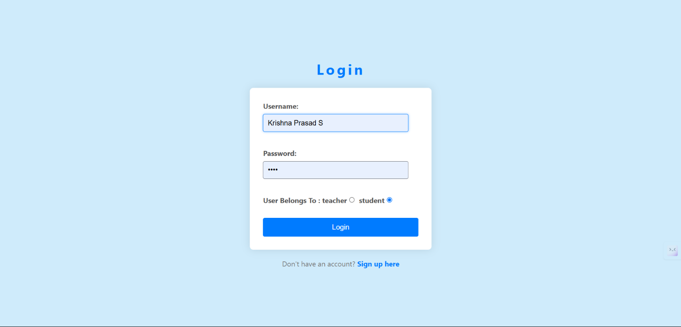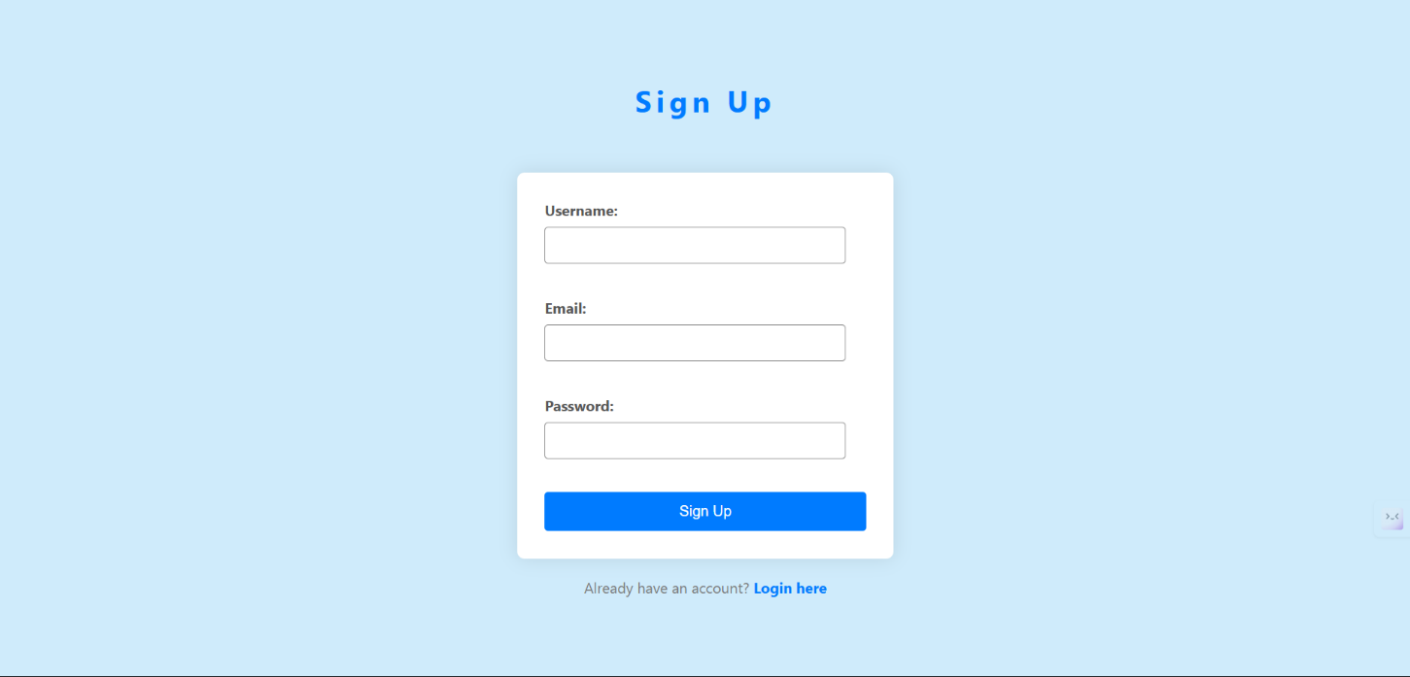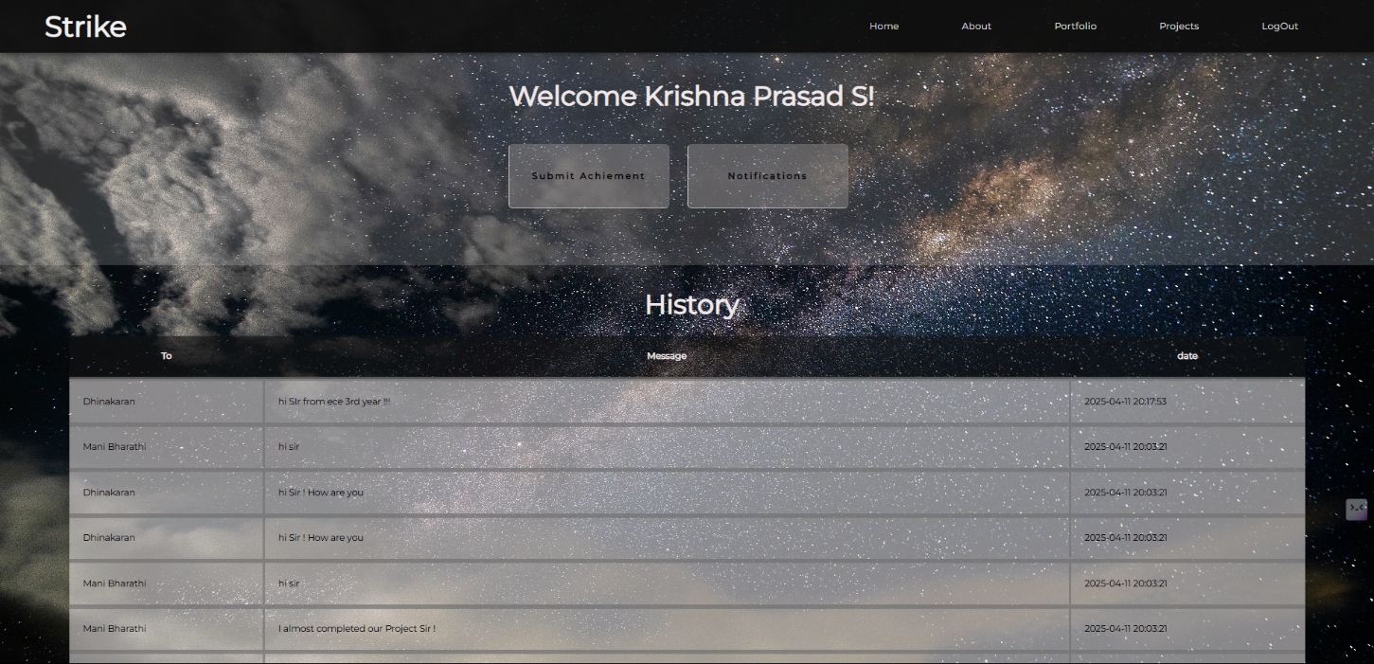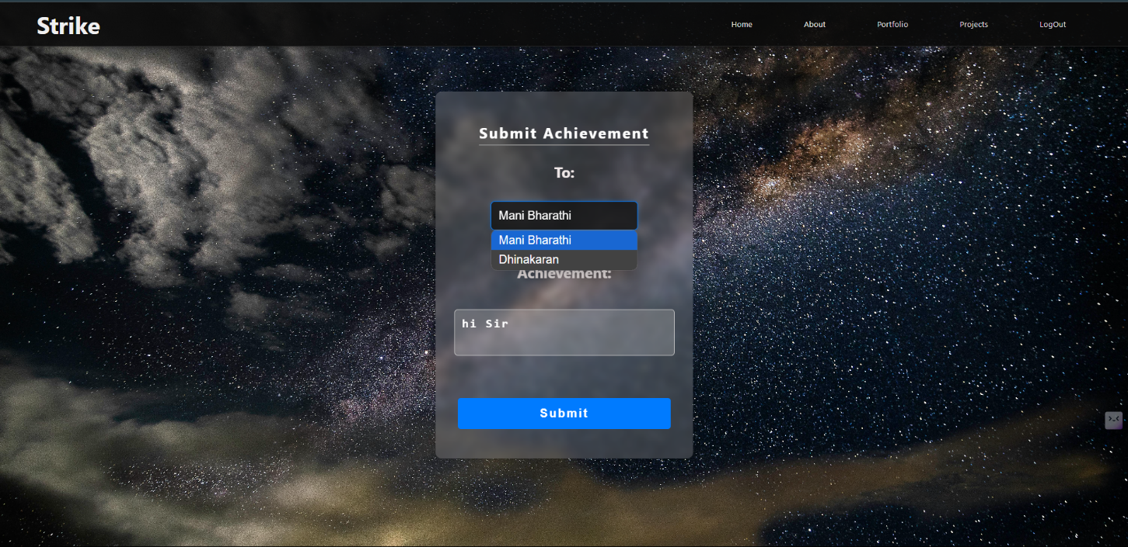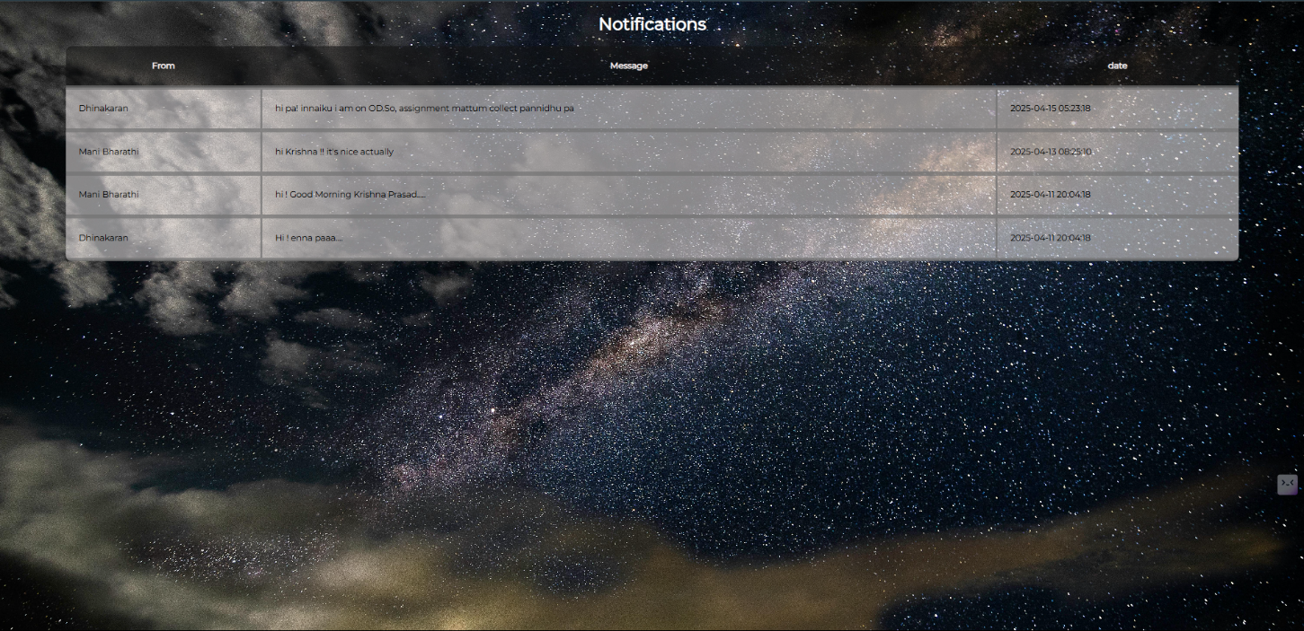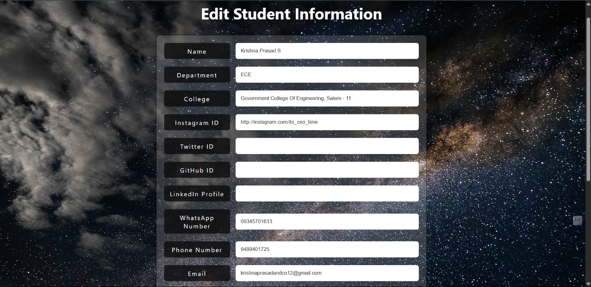

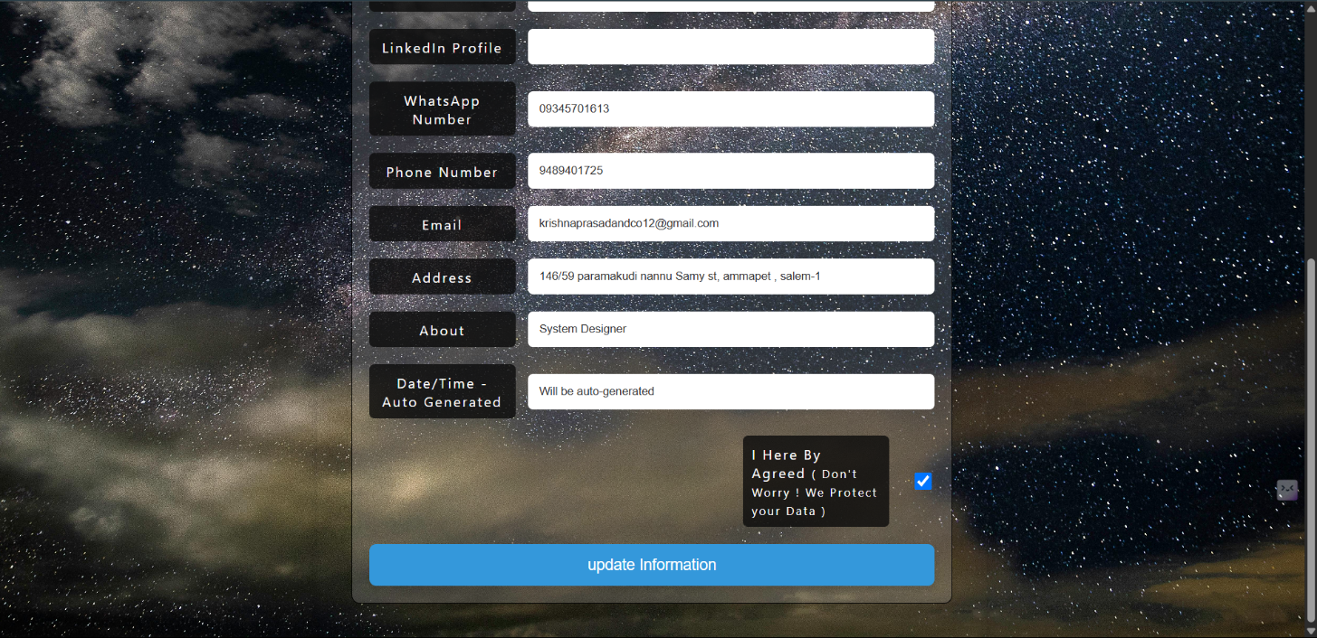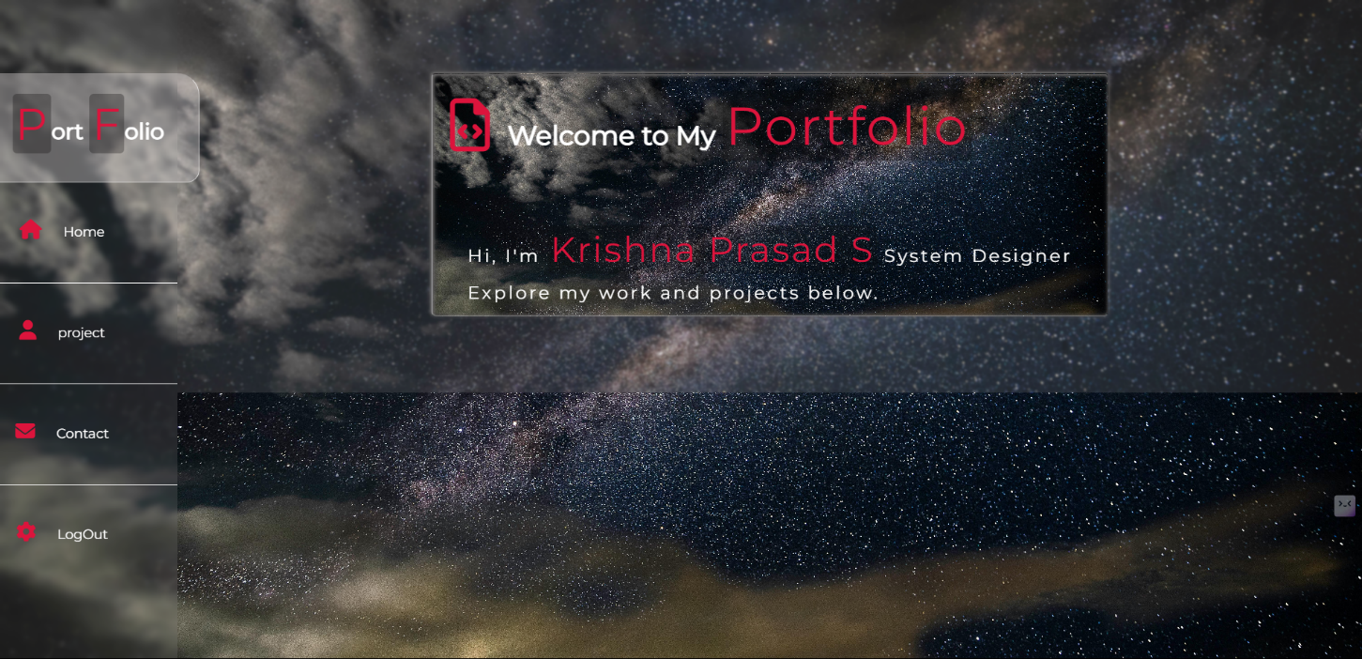

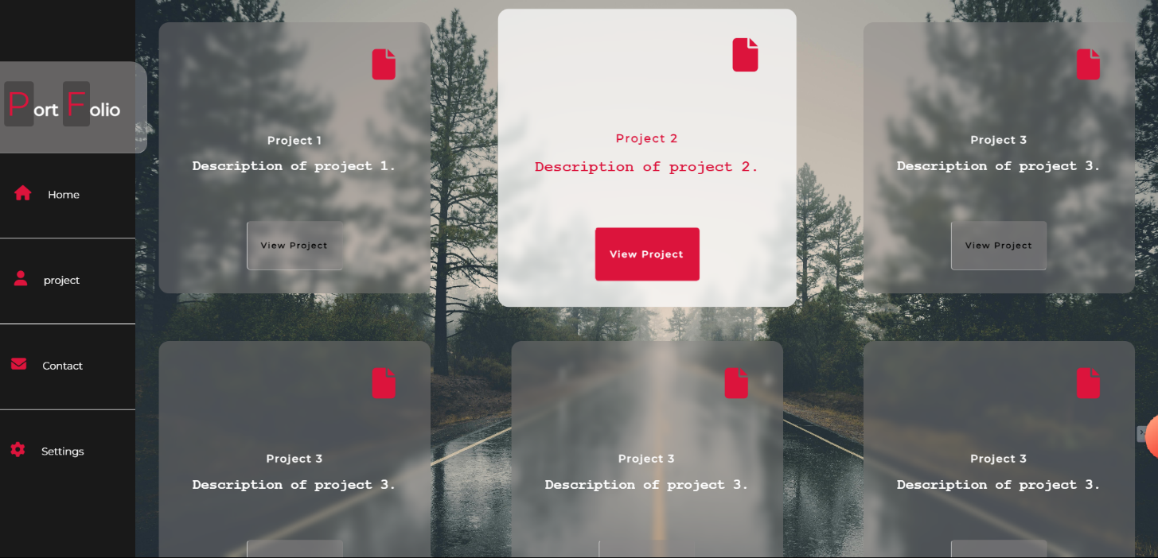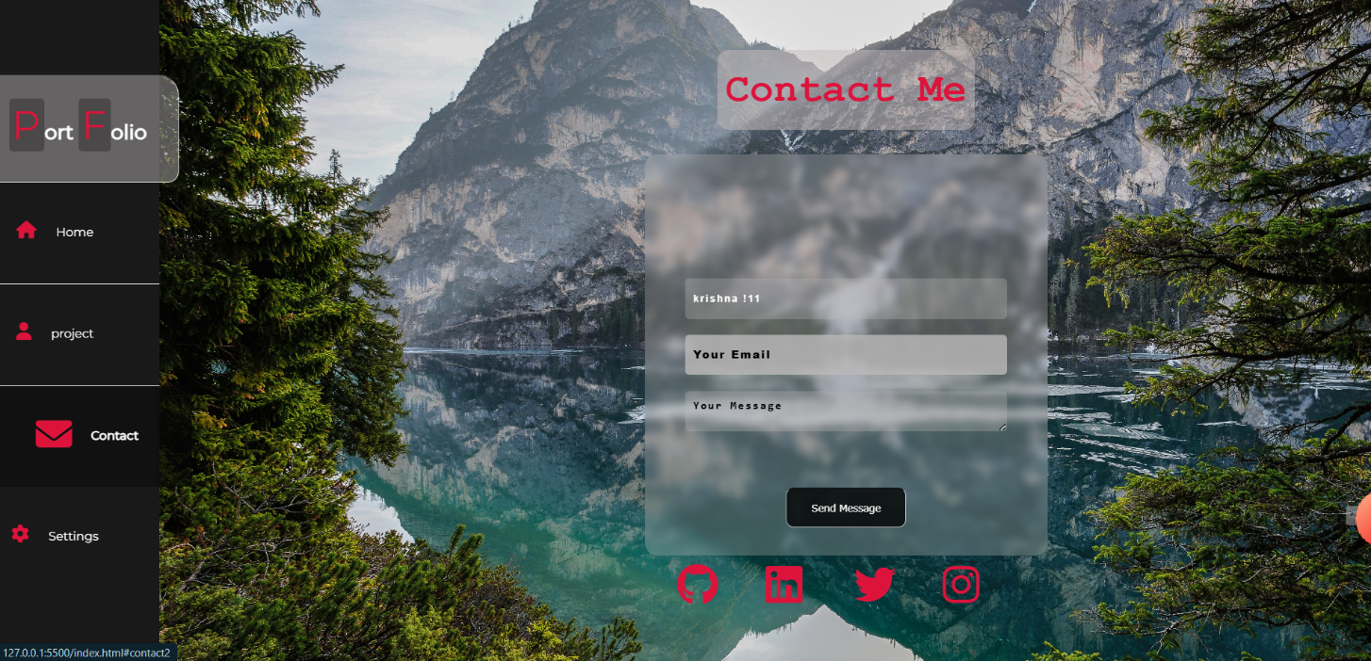

**>>> FROM TEACHER LOGIN/SIGN_UP**

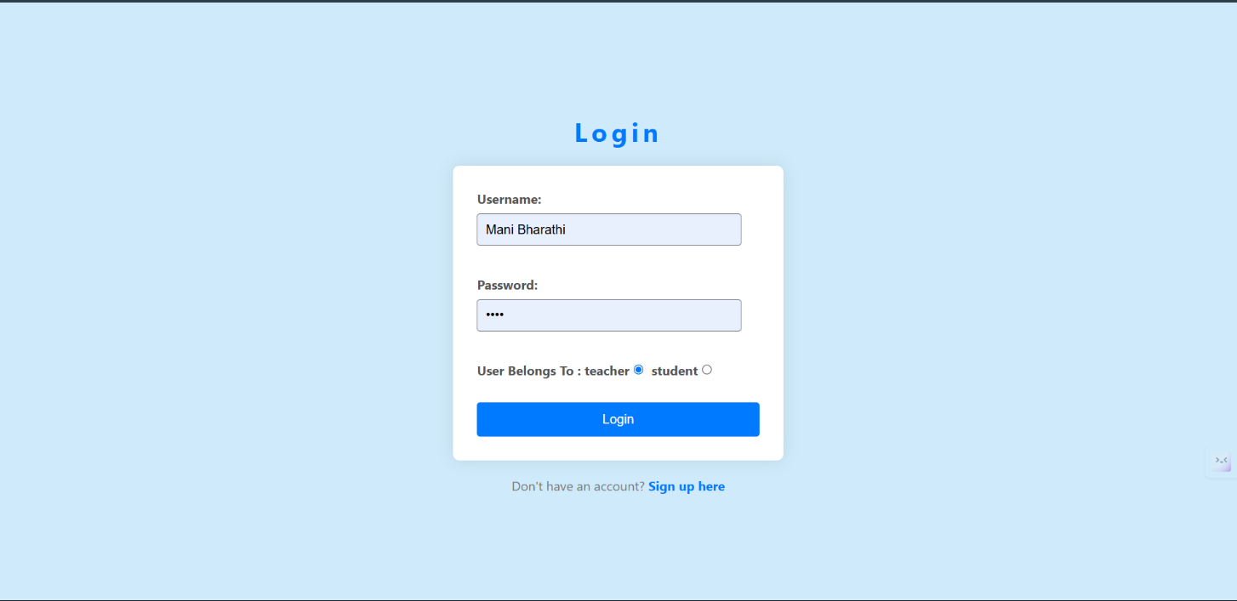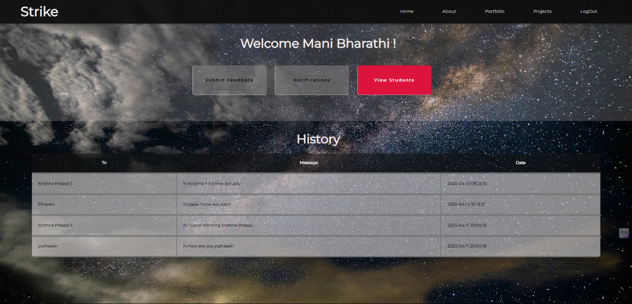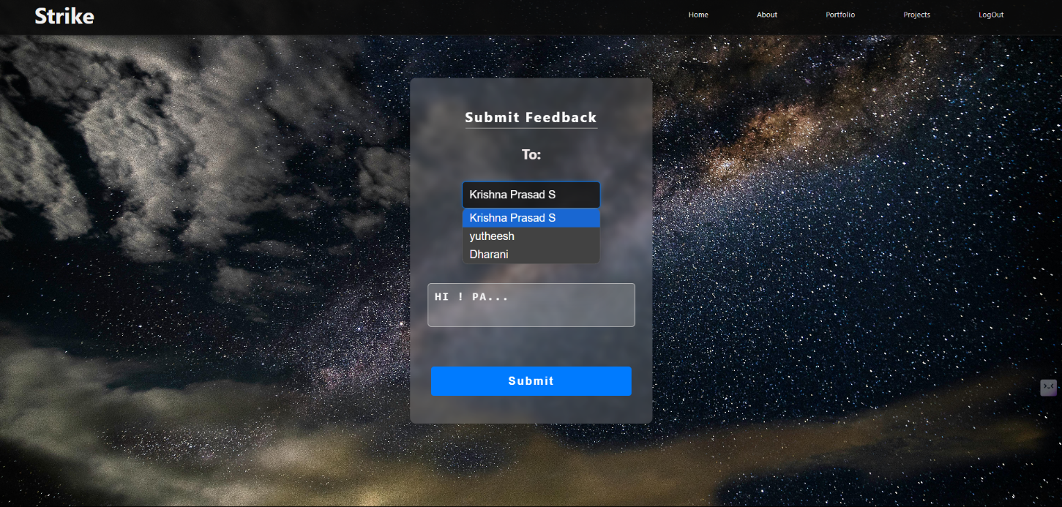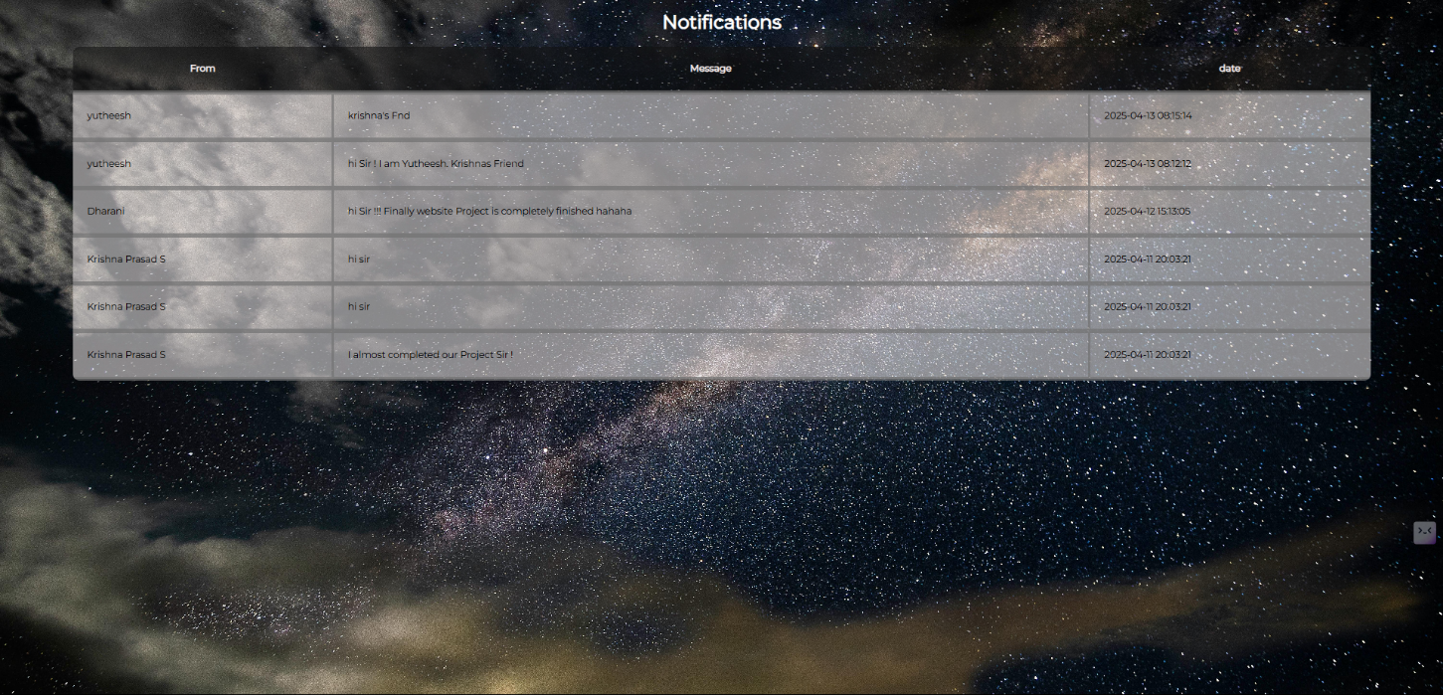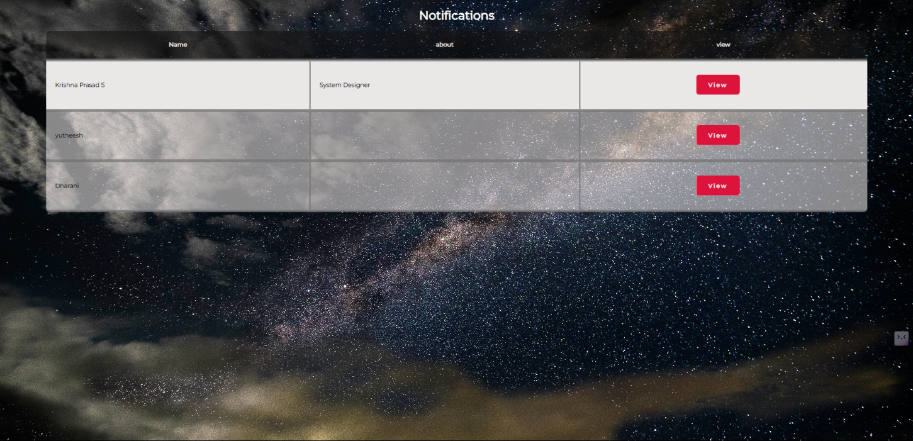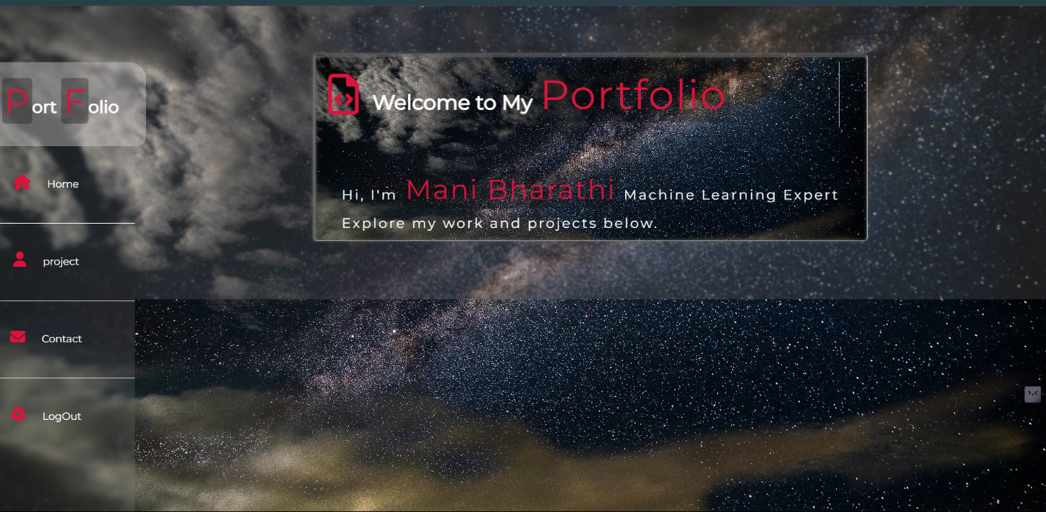



Team Mentor :

Prof. D. ManiBharathi

Assistant Professor

ECE DEPARTMENT

Government College Of Engineering, Salem - 11.

🙏 Special Thanks

We would like to express our heartfelt gratitude to our advisor, Prof. D. ManiBharathi.

whose guidance, support, and vision laid the foundation for this project.

“It was Sir's idea that planted the seed for building a platform to track student achievements and we, as a team, feel honored to bring it to life.”

Your encouragement meant everything to us. Thank you for believing in our team!

**Team Members**

This project was made possible by the dedication, hard work, and collaboration of an amazing team:

Kritick Raj & Sudharsan

>>> 🫶 Thank you all for turning this idea into reality. This tracker isn't just a tool — it’s a symbol of our teamwork, dedication, and vision!

**Contact**

For support, questions, or feedback, please contact:

* **Project Maintainer:** Krishna Prasad S
* **Email:** krishnaprasadandco12@gmail.com
* **GitHub: // Processing…**

**Contributing**

Contributions are welcome! Please follow these steps: 🡪 Fork the repository.

1. Create a new branch (git checkout -b feature/your-feature).
2. Commit your changes (git commit -am 'Add new feature').
3. Push to the branch (git push origin feature/your-feature).
4. Open a Pull Request.

**License**

This project is licensed for educational and non-commercial use. For commercial use or further licensing details, please contact the maintainer.

**Note:**  
Ensure your server environment meets the prerequisites. For any issues, please check the PHP error logs or contact the maintainer.